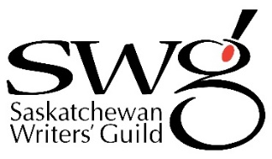

2021 John V. Hicks Long Manuscript Award –
Poetry

Applicant Information
Name
Address
City
Province |  | Postal Code
Phone
Email
Title of Work submitted
Word Count |  | Date

I confirm the following:

☐ I am a resident of Saskatchewan as of December 31, 2020.

☐ The work is original to me.

☐ The work will not be published before the announcement of the awards in October (although it may be accepted for publication).

☐ No more than 50% of the manuscript has been previously published or broadcast.

I am paying my $25 entry fee by:
☐ Online payment
☐ Cheque
☐ Credit card

