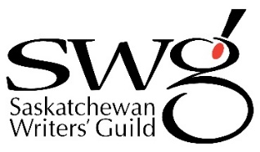

Submission to the 2024 John V. Hicks Long Manuscript Award –
Poetry

Applicant Information
Name
Address
City
Province |  | Postal Code
Phone
Email
Title of Work submitted
Word Count |  | Date

I confirm the following:

☐ I am a resident of Saskatchewan as of December 31, 2023.

☐ The work is original to me.

☐ The work will not be published before the announcement of the awards in October (although it may be accepted for publication).

☐ No more than 50% of the manuscript has been previously published or broadcast.

I am paying my $35 entry fee by:
☐ Credit card online www.skwriter.com
☐ Credit card by phone call 306-791-7740 Mon-Fri 8:30-4:30
☐ Etransfer to director@skwriter.com
☐ Cheque enclosed with manuscript

