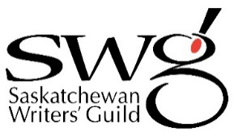
Saskatchewan Poet Laureate Application Form
Contact Information
Name
Address
City |  | Postal Code
Phone
Email
☐ I confirm that I am a current resident of Saskatchewan, and have been a resident for at least 2 of the past 3 years
Application Package
Please ensure your application package includes the following:
☐ | Saskatchewan Poet Laureate Application Form (this form)
☐ | Curriculum Vitae (max 5 pages) including a brief bio, a complete list of publications and evidence of your involvement in the literary life of Saskatchewan
☐ | A letter of intent (max 750 words) that explains:  - Why you want to be the Saskatchewan Poet Laureate  - How you meet the criteria of the position you are applying for  - How you would like to engage people in poetry through an event, initiative or community visits. Activities must adhere to the objectives of the Poet Laureate program and should be publicly accessible.  - Your availability and ability as the nominated poet between Aug 1, 2023 – July 31, 2025.
☐ | Up to 3 letters of reference

Please submit your application package by email to programs@skwriter.com by midnight Wednesday May 31, 2023.

For more information, please contact: | Yolanda Hansen, Program Manager  306-791-7743 or programs@skwriter.com

